1. Make at least 0.5mm clearance both sides in two circled regions

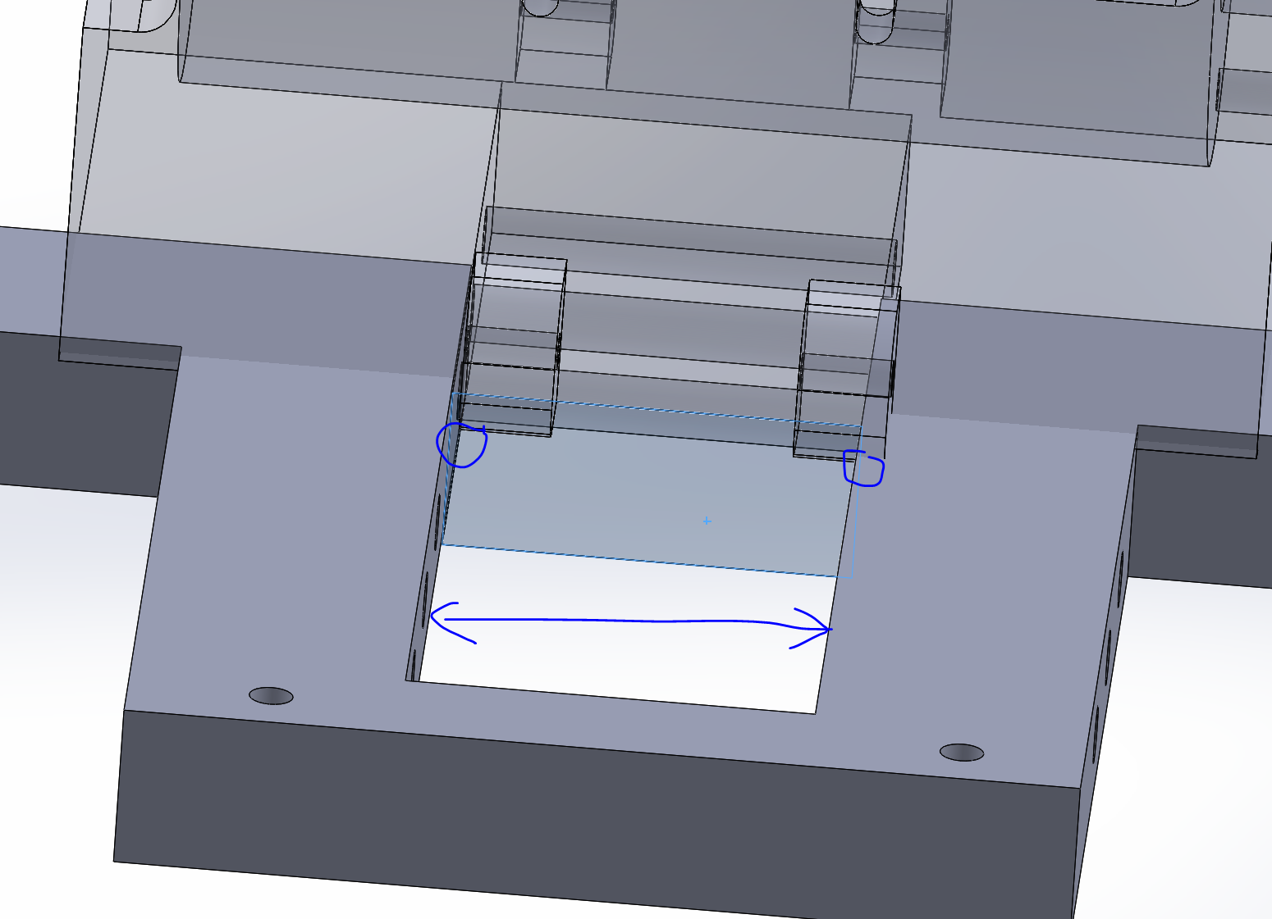

1. Holes are undersized. 1/4in bolt is 6.35mm OD, and the holes are sized exactly the same. Will have difficulty pushing through. Recommend minimum 6.6mm OD for holes.

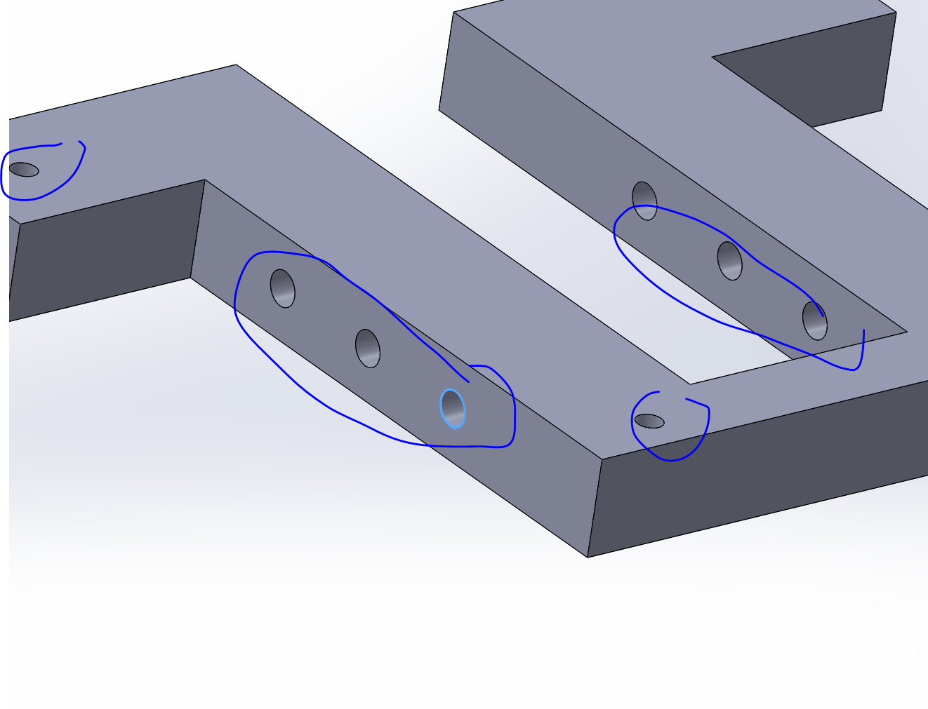

Same for here as well:

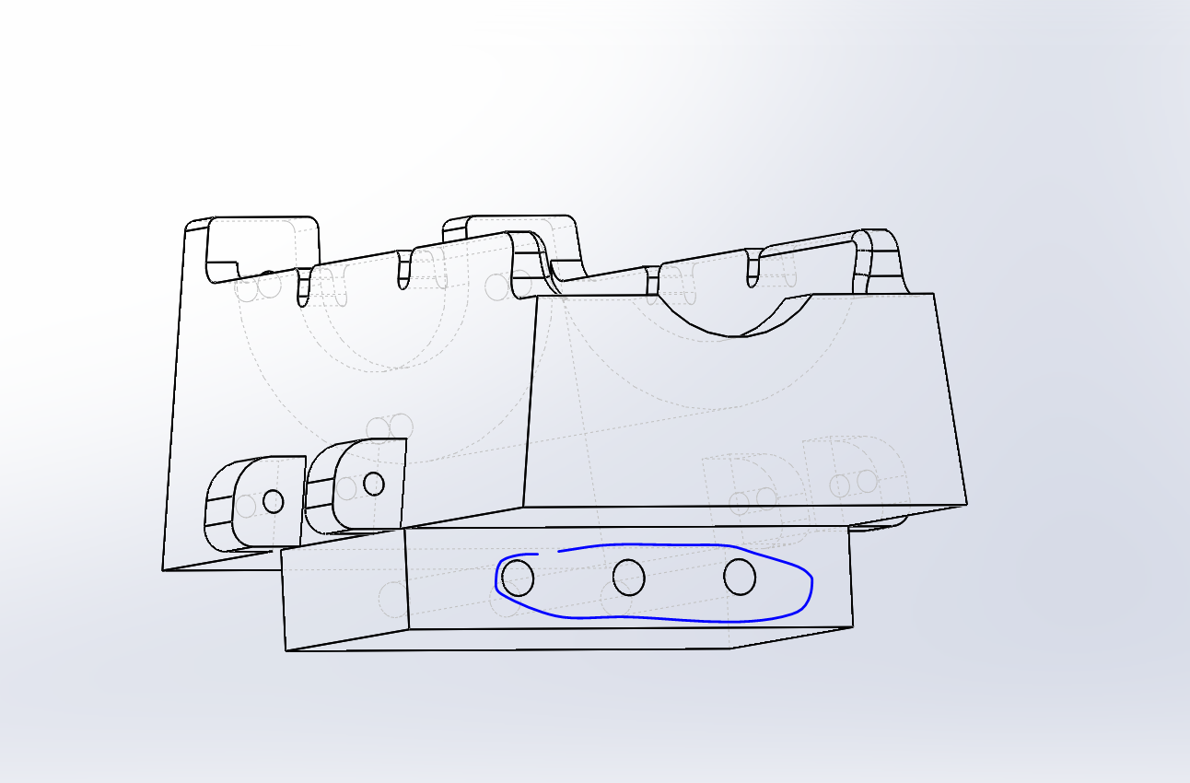

1. These holes are sized exactly same as screw. Recommend 5.11mm OD for three holes here

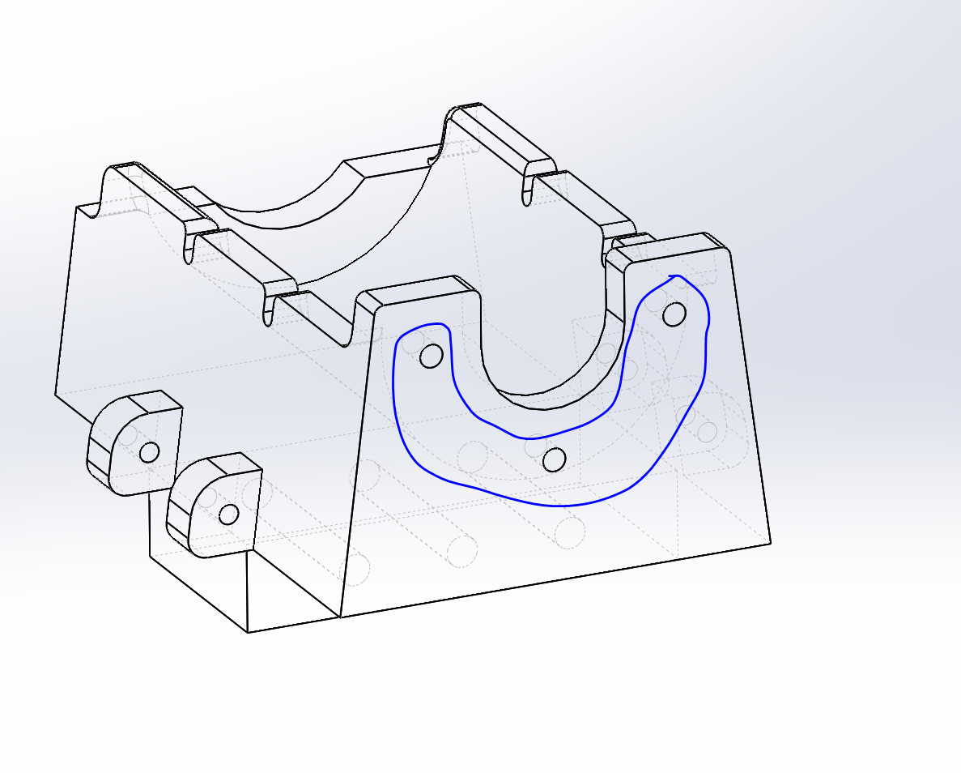

1. Concerned regarding clearance and assembly. The bolt head is 0.505in max OD, meaning it will be difficult to assemble with a screw. Recommend moving bolt position down by another 0.5cm.

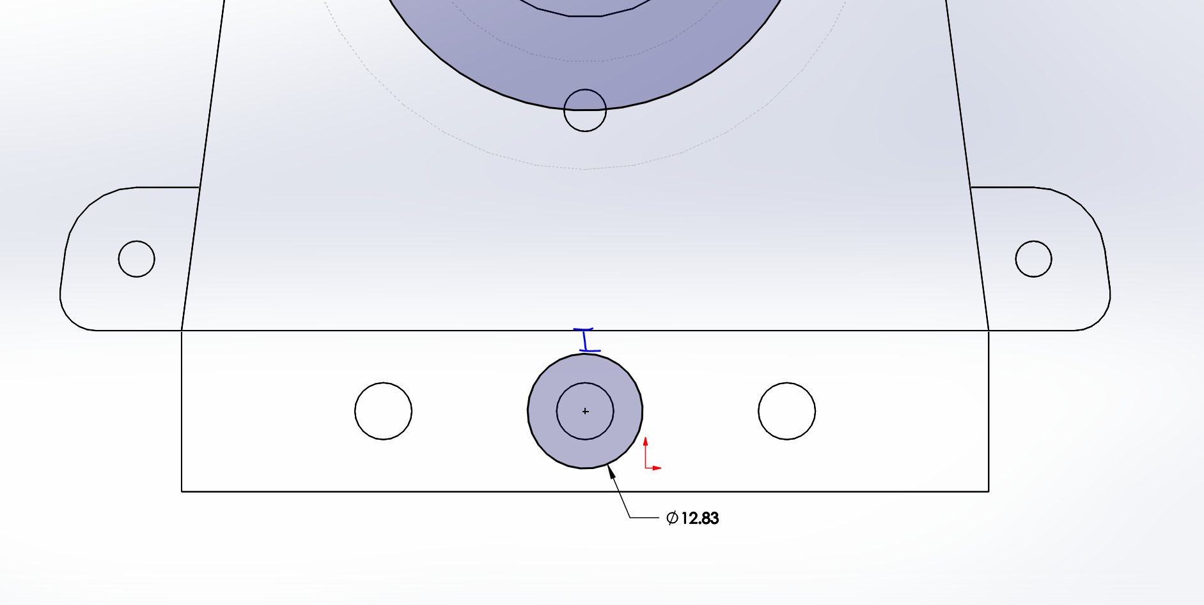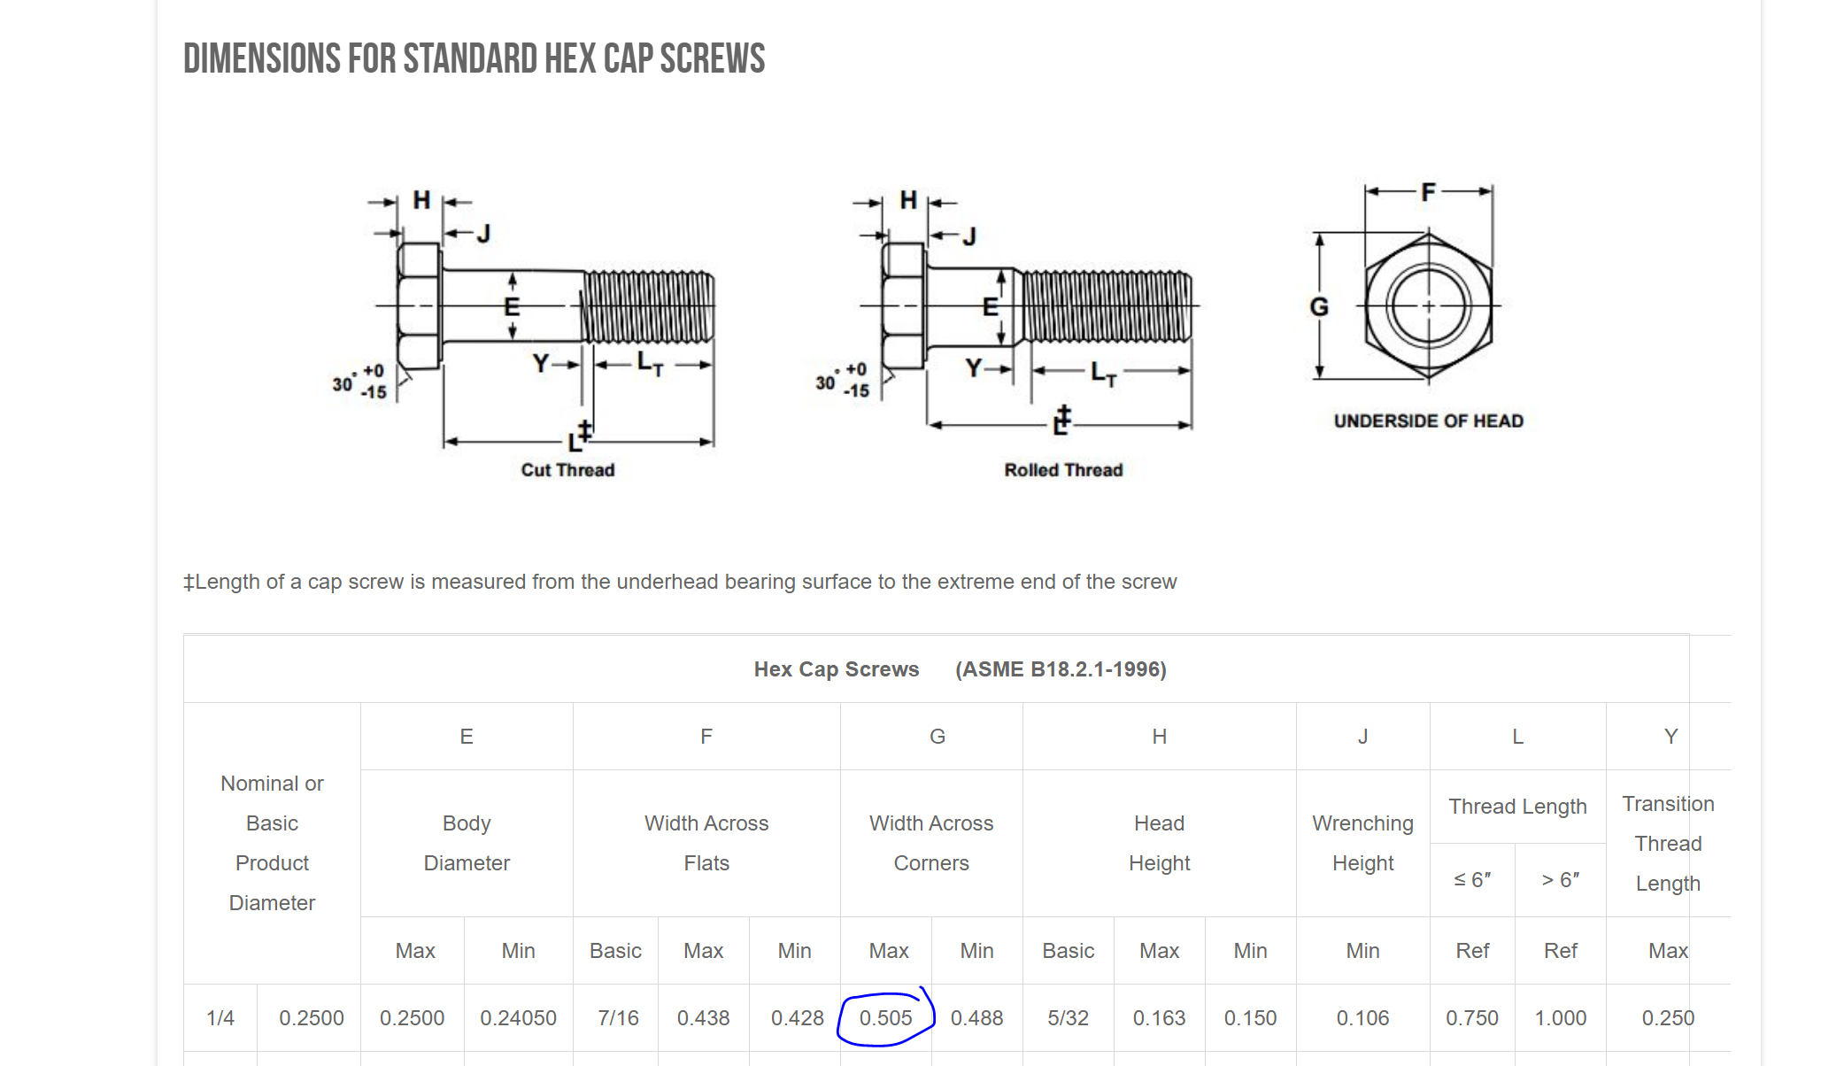

1. Increase thickness to 10mm. The screws will hit the end of the motor below this.

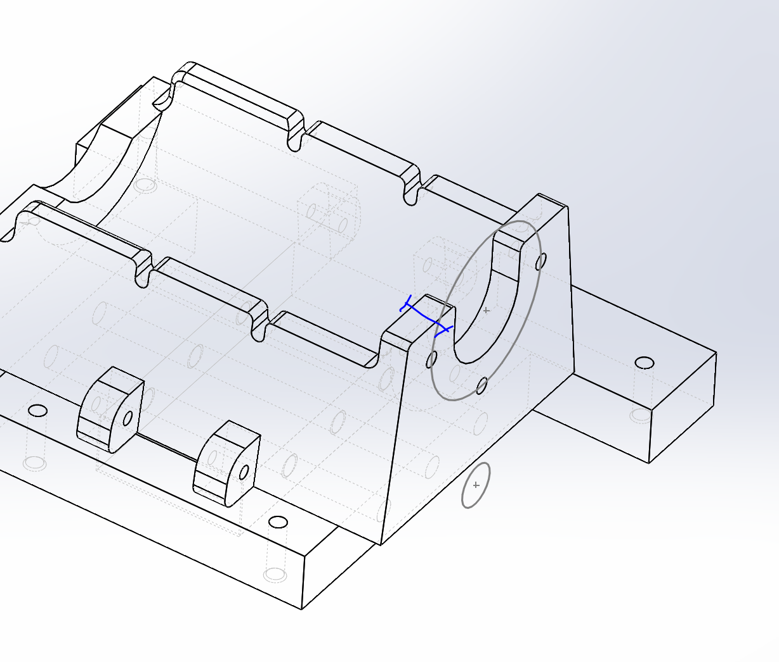

1. Increase diameter to at least 2.6in. Currently is undersized at 32mm radius

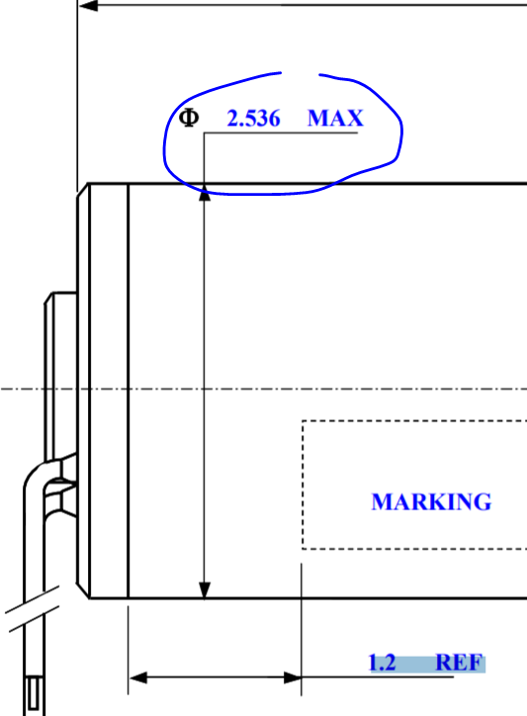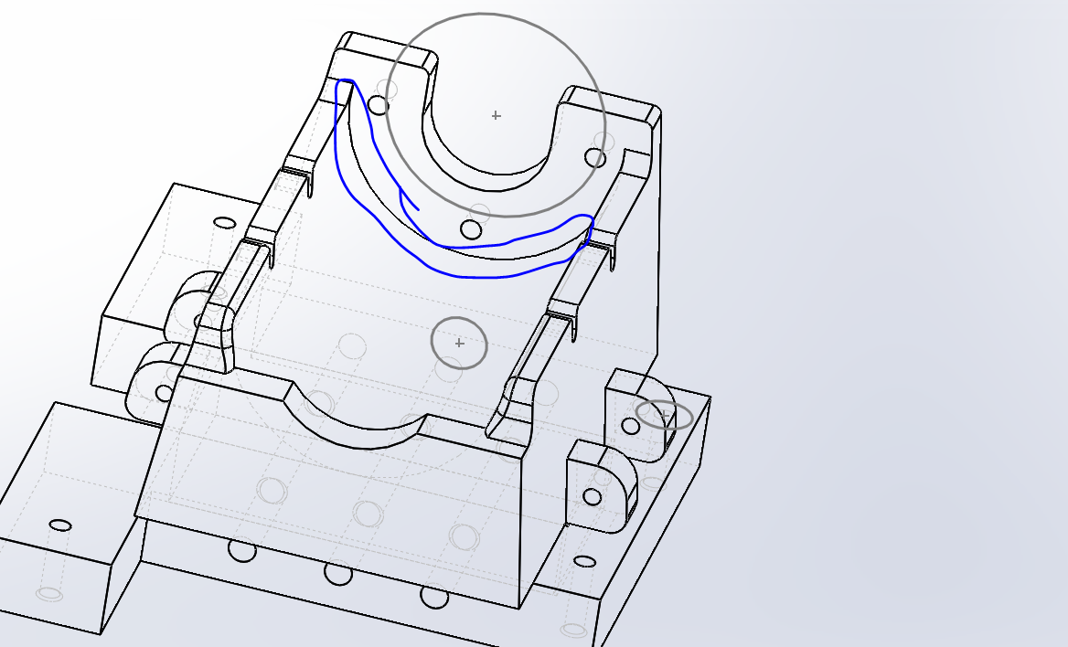

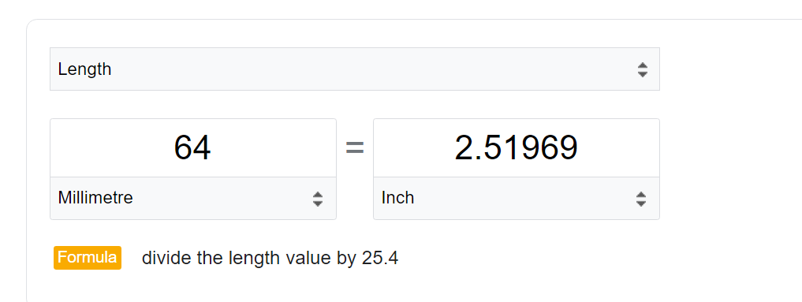

1. Based on assumption that small holes are using 10-32 bolt (metric), the gap is too small for head of bolt. In addition, the holes should be clearance holes. Currently all small diameters are 4.8mm. Should be minimum 10.8mm.

